**Good luck guys :)**

**1.1 What is described by 𝑨𝑻𝑨 and 𝑨𝑻? Draw a scenario containing a lidar sensor, a target that gets detected by the lidar and the corresponding Lidar field of view for 𝑨𝑻𝑨 < 𝑨𝑻 (𝑹𝟎) in the scenario.**

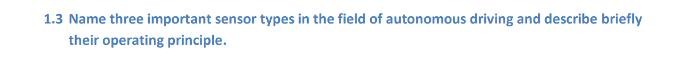

1. Interoceptive sensors: Sensors on or in the car perceiving the ego car state and

its interior. Examples: gyros, accelerometers, steering angle sensors, wiper

1. Exteroceptive sensors: Sensors on or in the car perceiving the vehicle’s

surroundings. Examples: Radars, lasers, ultrasonic sensors, cameras.

1. Meta sensors: Often a source of data derived from measurements of other

entities or sensor types. Examples: cloud data, navigation maps, Car2X.

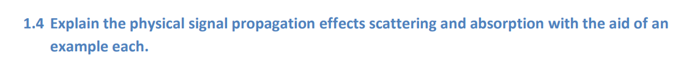1) Absorption: Loss of energy of propagating wave while traveling through a medium. Example: laser rays being absorbed by carbon black in concrete from roads, thus returning only little light back to the lidar receiver.

2) scattering: Radiation such as light being forced to deviate from straight path due to

localized non uniformity in propagation medium.

Example: Lidar in the rain. The drops make the rays deviate from their original course.

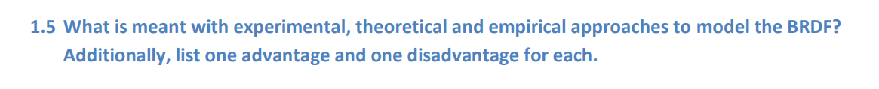

Experimental: Measure BRDF with gonioreflectometer varying light sources and sensor positions. Slow. Limited data. Limited resolution.

Empirical: Provide simple formulation to mimic specific kind of reflection. Low computational cost, adjustable by parameters, without consideration of physics.

Theoretical: Accurately simulate light scattering by using physics laws Complex expression. High computational effort.



Correct: All the path internal configurations are valid (collision free), The motion between the configurations are executable.

Optimal : Time or distance, Safety: low risk, Comfort: smooth, Eco: energy consumption

Complete: Decide whether a solution exists in a finite amount of time, If a solution exists, return one solution in finite time

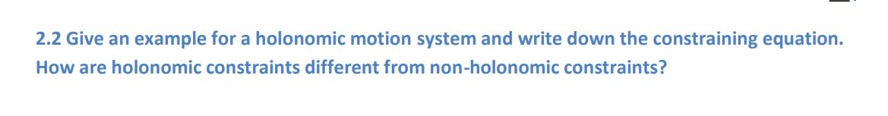

Example: Snake game

Constraint: let x, y be the position of the head of the snake. Then 0 < x < WIDTH, 0< y< HEIGHT.

Holonomic vs non-holonomic: Non-holonomic would present constraints using the derivatives of the variables.

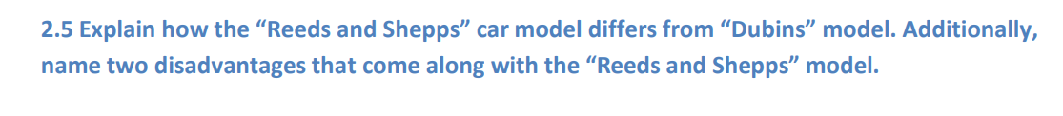

The Dubnis model presents a set of “words” on which the car can operate, made of 3 actions {L, R, S}. In total, we have 6 possible options.

The Reeds and Shepps model adds the motion of going back in reverse. That increases the action space to 48 possibilities.

That means, it might be more expensive computationally (runtime) to find a path

Disadvantages: No continuous curvature, Small position changes can lead to large differences concerning path length.

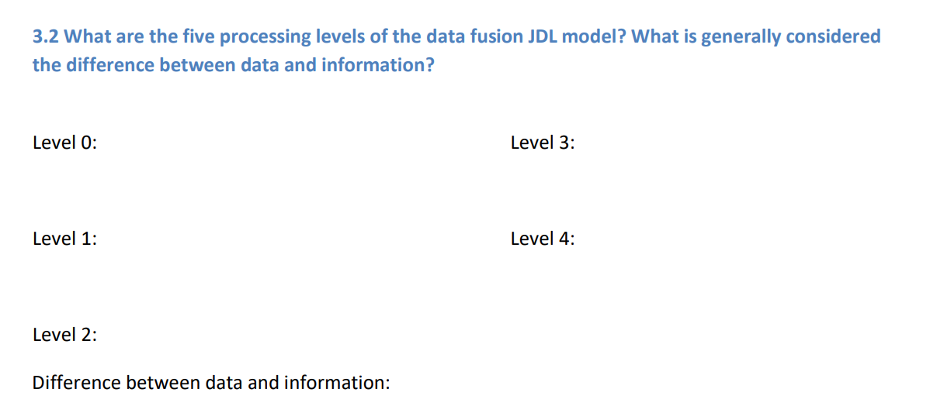

**Data is a collection of facts**. Information is how you understand those facts in context. Data is unorganized, while information is structured or organized.

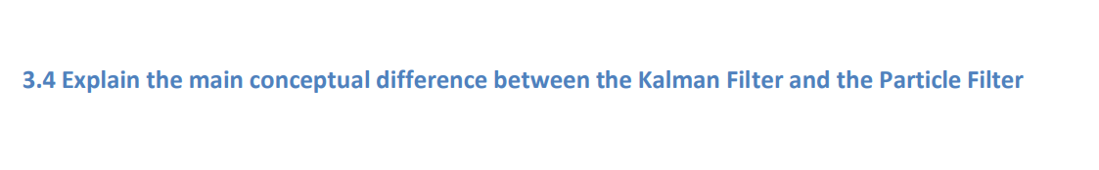Kalman Filter is a linear filter that assumes Gaussian. The relevant variant of it is the Unscent Kalman filters that samples points, assumed from a Gaussian, passes them through non-linearity and reconstructs a Gaussian out of the “image” (results of function). The Particle Filter has the same logic like the Unsent Kalma Filter, does not assume what the distribution is.



CNN

Auto Encoders

LSTM (RNN) - to intreprtate road signs etc.

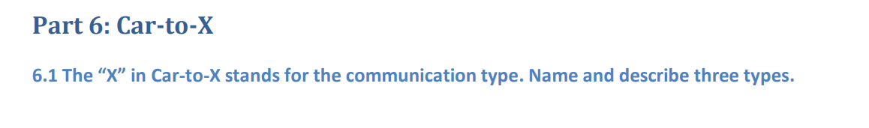

V2X - Vehicle to Everything